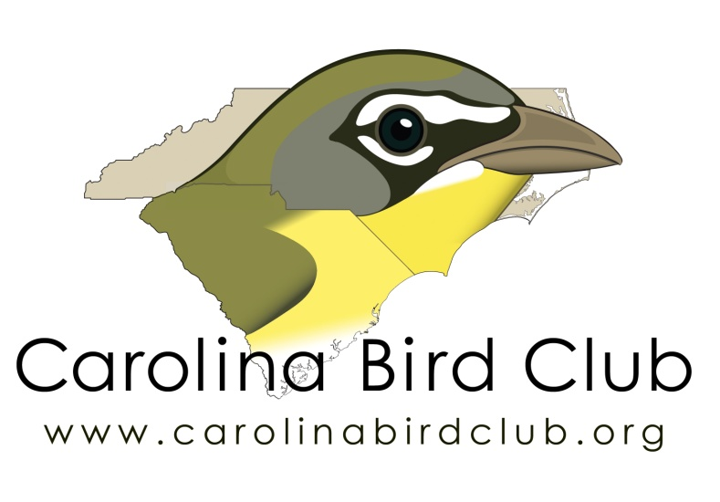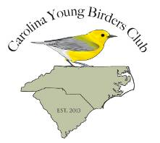
Carolina Bird Club
Scholarship Application form
Seasonal Meeting

Applicant Name:
Age at date of the seasonal CBC meeting:
Address:

Phone: __________________________________
Cell (optional)_____________________________
Email___________________________________

Parent or legal guardian
Signature: ____________________________________________________
Note that for scholarship recipients who are under 18 years old at the time of the CBC seasonal meeting, parents must sign a separate waiver form upon the scholarship recipient’s registration for and prior his / her attendance at the CBC seasonal meeting.

Applicant
Signature:

Date and location of the seasonal CBC meeting___________________________
_____________________________________________________________
I am willing to present my essay at a seasonal CBC meeting: Y____N____
I will submit an essay for the CBC Newsletter or Chat: Y____N____
I am willing to volunteer at this meeting: Y______N______

Carolina Bird Club
Scholarship Application Form
Seasonal Meeting

Submit a brief essay of 250 words or greater that describes the following.

- Your interest in bird watching and the Carolina Bird Club.
- Any achievements or notable birding experiences in the Carolinas.
- Your level of participation, if any, in the current meeting including any previous volunteer projects.

In addition, please submit your anticipated expenses.

Applicants are welcome to submit letters of endorsement; either from teachers or adult birding mentors, affirming the applicant’s commitment to birds and birding.

We look forward to receiving your application!
(1 application per family)

