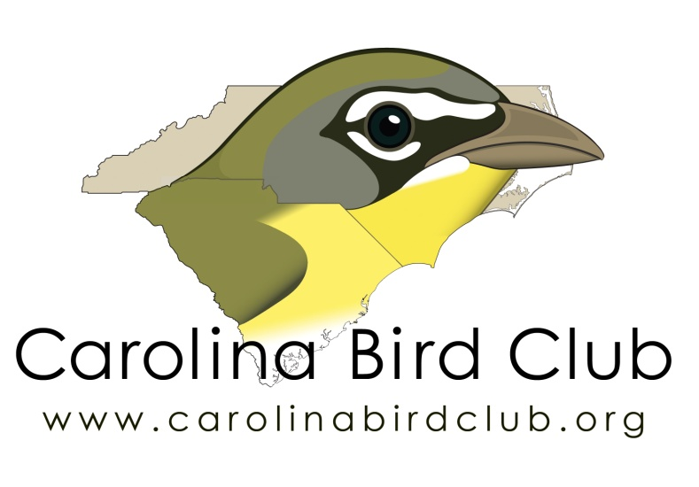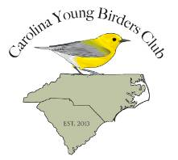
Camp Avocet
Carolina Bird Club
Scholarship Application Form

Applicant: ___________________________________________________
Age at date of the event:
Date of birth: _____________________________
Address: _____________________________________________________
_____________________________________________________________
Home Phone: _____________________________
Cell (optional): _____________________________
Email address_____________________________
ABA Membership #: _________________________
Campers Gender: __________
I am willing to present my essay at a seasonal CBC meeting: Y______N_____
I will submit an essay for the CBC Newsletter or Chat: Y_____N______

Applicant Signature________________________________________________

Parent/Guardian

Name/Relationship: ________________________________________________

Parent/Guardian Cell: _____________Home: ____________________________

Parent/Guardia email address: _______________________________________

Signature: _______________________________________________________

Camp Avocet

Carolina Bird Club

Scholarship Application Form

Please select from the options listed below and submit a short essay of no more than 750 words:
Essay Option 1
Describe a memorable birding experience and how it changed your thoughts, ideas, or outlook?
Essay Option 2
What is birding to you and how has it changed your world?
In addition, applicants are welcome to submit letters of endorsement; either from teachers or adult birding mentors, affirming the applicant’s commitment to birds and birding.

We look forward to receiving your application!

